Part number or Spare ID of HDD fixation for Gen8 server generation is 653957.
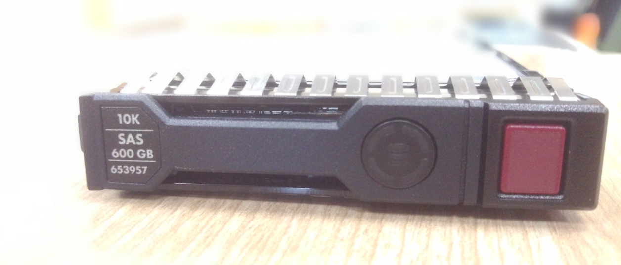

Part number or Spare ID of HDD fixation for G7 server generation is 581311-001.
